1. DNS Report
Domain 1: google.com
A records:
173.194.221.113
173.194.221.101
173.194.221.102
173.194.221.138
173.194.221.100
173.194.221.139

TTL:
310 seconds
Authoritative nameservers:
ns1.google.com
ns2.google.com
ns3.google.com
ns4.google.com

Explanation:
Google has several A records because large websites often use multiple IP addresses for load balancing and reliability. The TTL is 310 seconds, which means DNS resolvers can cache this answer for about 5 minutes.

Domain 2: wikipedia.org
A record:
185.15.58.224
TTL:
48 seconds
Authoritative nameservers:
ns0.wikimedia.org
ns1.wikimedia.org
ns2.wikimedia.org

Explanation:
Wikipedia has one A record in this result. The TTL is 48 seconds, which is low, so DNS resolvers should cache the answer only for a short time.

Domain 3: github.com
A record:
140.82.121.4
TTL:
37 seconds
Authoritative nameservers:
dns1.p08.nsone.net
dns2.p08.nsone.net
dns3.p08.nsone.net
dns4.p08.nsone.net
ns-421.awsdns-52.com
ns-520.awsdns-01.net
ns-1283.awsdns-32.org
ns-1707.awsdns-21.co.uk

Explanation:
GitHub has one A record in this result. The TTL is 37 seconds, which is very low, so DNS records can update quickly.
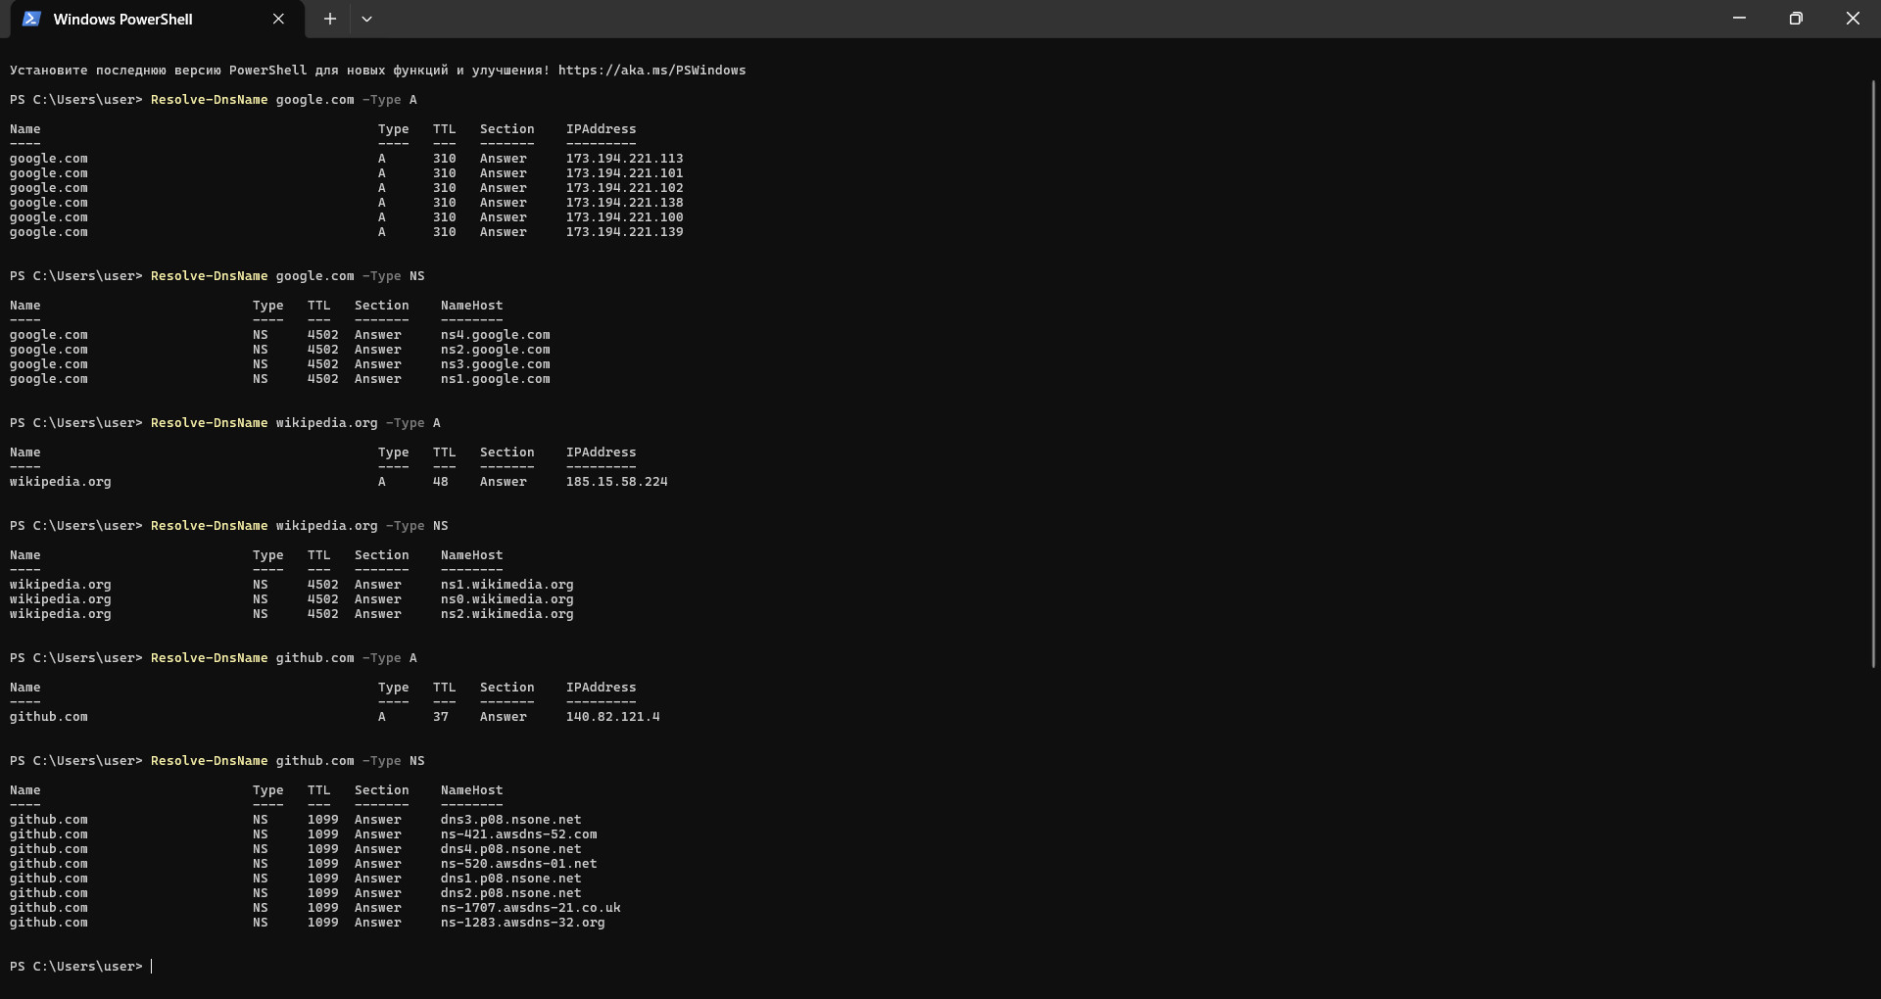

2. curl scavenger hunt

URL returning 200:

Command:
curl.exe -s -o NUL -w "%{http_code}`n" https://httpbin.org/status/200

Status code:
200

Explanation:
The 200 status code means that the request was successful. The server received the request and returned a successful response.

URL returning 404:

Command:
curl.exe -s -o NUL -w "%{http_code}`n" https://httpbin.org/status/404

Status code:
404

Explanation:
The 404 status code means that the requested resource was not found on the server.

3. Short written answer

Website:
https://www.wikipedia.org

I opened DevTools and checked the Network tab. Besides the main HTML document, the website made these requests:

Request 1:
Name: Wikipedia-logo-v2@2x.png
Status: 200
Type: png
Purpose: This request loads the main Wikipedia globe logo image that is displayed on the page.

Request 2:
Name: index-34f340e24a.js
Status: 200
Type: script
Purpose: This request loads a JavaScript file. JavaScript can add behavior and interactivity to the page.

Request 3:
Name: sprite-e49fbf32.svg
Status: 200
Type: svg+xml
Purpose: This request loads an SVG image sprite. It can contain icons or small vector graphics used on the page.

